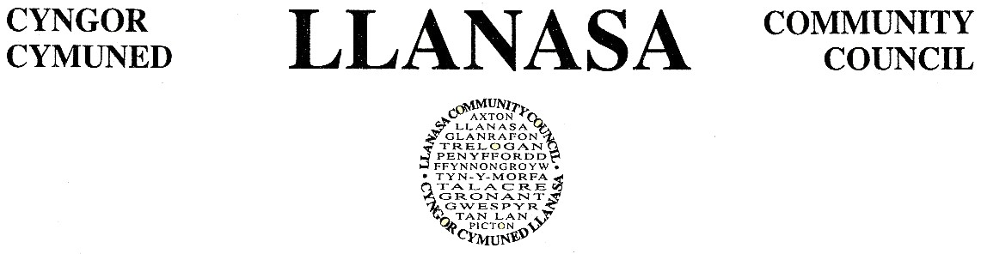

NOTICE UNDER LOCAL GOVERNMENT ACT, 1972 (Section 87(2))

VACANCY FOR A
COUNCILLOR
PUBLIC NOTICE IS HEREBY GIVEN
that a casual vacancy has occurred in the office of Councillor for the Ffynnongroyw Ward of the Community of Llanasa following the resignation of Councillor Dorothy Banks.

1 | Rule 5(2) of The Local Elections (Parishes and Communities) (England and Wales) Rules, 2006 now applies.
2 | The rule allows TEN ELECTORS for the Community in which the casual vacancy has arisen to request the Returning Officer to hold an election to fill the vacancy. * That request must be made within FOURTEEN DAYS, calculated in accordance with the rules,** of the date of this notice. The fourteen-day period ends on Thursday 12th September 2024.
3 | If no request is made the Community Council must, as soon as practicable after the expiry of the fourteen-day period, co-opt a person to fill the vacancy.
The Returning Officer’s address is Flintshire County Council, County Hall, Mold, Flintshire. CH7 6NR and the telephone number for further guidance is 01352 702329.

Dated:
Clerk to the council
Mrs. Lydia Harvey

